# Power Supply

# Introduction

The purpose of this document is to describe the Power Supply block of the Wearable Sensor for the Blind ECE Senior Capstone Project to other engineers with enough detail such that they would be able to reproduce and test this block using only this document as reference. The Power Supply block is implemented using 4 AA batteries in series connected to a 3.3V, 3A Regulator from Texas Instruments. Included in this document are an overview of the block, a schematic and wiring diagram, the properties of the interfaces with the other blocks in the system and testing procedures for each, and reasoning for why this design is the best solution for this block.

# Block Overview

The Power Supply block will provide power to every component in the system. The output voltage must be stable since sensitive sensors are being used. Roughly an Amp will be drawn continuously by the system when in use, so a high current capability is required. Fig. 1 below shows the black box diagram of the block. All the properties for these interfaces can be found in Table I. Sean Sylwester completed this block.

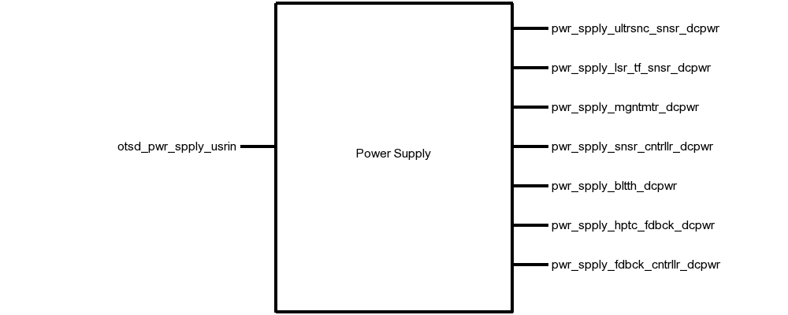

# Fig. 1. Black Box Diagram of the Power Supply Block

# Table I. Power Supply Block Interfaces And Properties

| **Name** | **Properties** |
| --- | --- |
| *otsd_pwr_spply_usrin* | 1. Timing: Low-Power Mode Battery Life: 24h 2. Timing: Standard Mode Battery Life: 12h 3. Type: AA Batteries (4x) 4. Usability: Time to Change Batteries: <1min |
| *pwr_spply_ultrsnc_snsr_dcpwr* | 1. Inominal: 5mA ± 10% 2. Ipeak: 30mA 3. Vmax: 5.5V 4. Vmin: 3V |
| *pwr_spply_lsr_tf_snsr_dcpwr* | 1. Inominal: 35µA ± 10% per sensor (between measurements) 2. Ipeak: 30mA per sensor (during measurement) 3. Vmax: 3.5V 4. Vmin: 2.6V |
| *pwr_spply_mgntmtr_dcpwr* | 1. Inominal: 5µA ± 10% (standby) 2. Ipeak: 0.5mA (measurement) 3. Vmax: 3.6V 4. Vmin: 1.95V |
| *pwr_spply_snsr_cntrllr_dcpwr* | 1. Inominal: 35mA ± 10% (Bluetooth Paired, with laser, Bluetooth, ultrasonic) 2. Inominal: 60mA ± 10% (Bluetooth Not Paired, with laser, Bluetooth, ultrasonic) 3. Vmax: 12V 4. Vmin: 3.4V |
| *pwr_spply_bltth_dcpwr* | 1. Inominal: 35mA ± 10% (During Pairing) 2. Inominal: 15mA ± 10% (after pairing) 3. Vmax: 6V 4. Vmin: 3.6V |
| *pwr_spply_hptc_fdbck_dcpwr* | 1. Inominal: 50mA ± 20% at 100% duty cycle 2. Ipeak: 75mA (per motor) 3. Vmax: 3.3V 4. Vmin: 2.7V |
| *pwr_spply_fdbck_cntrllr_dcpwr* | 1. Inominal: 9mA ± 10% 2. Ipeak: 20mA 3. Vmax: 5.5V 4. Vmin: 1.8V |

# Verification

This section details the testing procedures to verify every property listed in Table I. All tests must be passed successfully before this block will be integrated into the rest of the system.

## Battery Testing

This test will verify the battery properties in the *otsd_pwr_spply_usrin* interface, and all the power interfaces to this block. The currents being drawn from the system more than cover the nominal and peak current requirements in each power mode.

1. Connect 4 new AA batteries in series to the 3.3V voltage regulator.
2. Connect a DC load set to the nominal low-power mode current draw of 140mA to the output of the voltage regulator.
3. Wait 24h, then check the output voltage of the regulator and the battery output voltage.
4. Connect 4 new AA batteries in series to the 3.3V voltage regulator.
5. Connect a DC load set to the nominal standard mode current draw of 250mA to the output of the voltage regulator.
6. Wait 12h, then check the output voltage of the regulator and the battery output voltage.

PASS: The power supply continues to provide 3V-3.3V from the regulator, and 3.6V-6V from the raw battery output after 24h runtime in low-power mode, and after 12h in standard power mode.

[Link to Video](https://drive.google.com/drive/u/1/folders/1gXpgcJuc-lXbEaQoLGY29z_sF6j2P20Q)

## User Interface Testing

This test will verify the user interface property in the *otsd_pwr_spply_usrin* interface

1. Blindfold a tester.
2. Give the blindfolded tester 4 new AA batteries, a screwdriver, and the enclosure with the batteries to be replaced.
3. Time how long it takes for the blindfolded tester replace the batteries.

PASS: 9/10 blindfolded testers are able to change the batteries in less than 1 minute.

[Link to Video](https://drive.google.com/drive/u/1/folders/1gXpgcJuc-lXbEaQoLGY29z_sF6j2P20Q)

# Design

The schematic in Fig. 2 presents this block’s wiring diagram, including the interfaces of this block to the rest of the system. Fig. 3 shows the schematic for the power supply portion of the PCB.

This block is implemented using 4 AA batteries connected to the input of a UCC283T-3 Low-Dropout Linear Voltage 3.3V/3A Regulator. Two 4.7µF smoothing capacitors are placed at the input and output of the regulator. Two switches are used: one for the main power on/off, and one to enable/disable the low-power mode. The low-power mode switch has a 10kΩ pull-down resistor connected to it to prevent a floating signal when low-power mode is disabled.

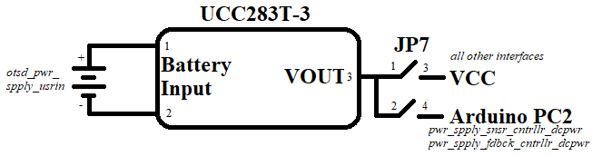

Fig. 2. Wiring Diagram for the Power Supply Block

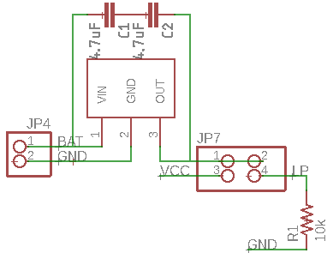

Fig. 3. Power Supply Schematic

## Design Validation

For this block, the UCC283T-3 regulator was used because it more than covers the 3.3V/1A power requirement that this project required of the Power Supply block and can be powered continuously with 4 AA batteries as their voltage drops over usage time. Table II on the next page validates all the system properties using the UCC283T-3 Datasheet.

Table II. Interface Property Validation For The Laser ToF Sensor Block

| Property | Validation |
| --- | --- |
| *otsd_pwr_spply_usrin* | |
| **Timing: Low-Power Mode Battery Life:** 24h | (AA Battery capacity: 3500mAh [2]) / (low-power mode current: 140mA) > 24h |
| **Timing: Standard Mode Battery Life:** 12h | (AA Battery capacity: 3500mAh [2]) / (standard mode current: 250mA) > 12h |
| **Type:** AA Batteries (4x) | 4xAA Battery voltage: 4V-6V. This lies within the 3.45-9V input voltage range for the regulator, shown in page 3 of the UCC283T-3 datasheet [1]. |
| **Usability: Time to Change Batteries**: <1min | The user needs to remove two screws, shake out the old batteries, put it in the new batteries, and replace the screws. In our preliminary testing, this process took less than 30s, so <1min is reasonable. |
| *pwr_spply_ultrsnc_snsr_dcpwr* | |
| **Inominal:** 5mA ± 10% | The regulator will output up to 3A given our 4V-6V input range according to page 3 of the UCC283T-3 datasheet [1]. |
| **Ipeak:** 30mA | The regulator will output up to 3A given our 4V-6V input range according to page 3 of the UCC283T-3 datasheet [1]. |
| **Vmax:** 5.5V | The regulator will output 3.3V given our 4V-6V input range according to page 3 of the UCC283T-3 datasheet [1]. |
| **Vmin:** 3V | The regulator will output 3.3V given our 4V-6V input range according to page 3 of the UCC283T-3 datasheet [1]. |
| *pwr_spply_lsr_tf_snsr_dcpwr* | |
| **Inominal:** 35µA ± 10% per sensor (between measurements) | The regulator will output up to 3A given our 4V-6V input range according to page 3 of the UCC283T-3 datasheet [1]. |
| **Ipeak:**30mA per sensor (during measurement) | The regulator will output up to 3A given our 4V-6V input range according to page 3 of the UCC283T-3 datasheet [1]. |
| **Vmax:** 3.5V | The regulator will output 3.3V given our 4V-6V input range according to page 3 of the UCC283T-3 datasheet [1]. |
| **Vmin:** 2.6V | The regulator will output 3.3V given our 4V-6V input range according to page 3 of the UCC283T-3 datasheet [1]. |
| *pwr_spply_mgntmtr_dcpwr* | |
| **Inominal:** 5µA ± 10% (standby) | The regulator will output up to 3A given our 4V-6V input range according to page 3 of the UCC283T-3 datasheet [1]. |
| **Ipeak:** 0.5mA (measurement) | The regulator will output up to 3A given our 4V-6V input range according to page 3 of the UCC283T-3 datasheet [1]. |
| **Vmax:**3.6V | The regulator will output 3.3V given our 4V-6V input range according to page 3 of the UCC283T-3 datasheet [1]. |
| **Vmin:** 1.95V | The regulator will output 3.3V given our 4V-6V input range according to page 3 of the UCC283T-3 datasheet [1]. |
| *pwr_spply_snsr_cntrllr_dcpwr* | |
| **Inominal:**35mA ± 10% (Bluetooth Paired, with laser, Bluetooth, ultrasonic) | The regulator will output up to 3A given our 4V-6V input range according to page 3 of the UCC283T-3 datasheet [1]. |
| **Inominal:**60mA ± 10% (Bluetooth Not Paired, with laser, Bluetooth, ultrasonic) | The regulator will output up to 3A given our 4V-6V input range according to page 3 of the UCC283T-3 datasheet [1]. |
| **Vmax:**12V | 4xAA Batteries when fully charged will have a maximum voltage of 6V [2]. |
| **Vmin:** 3.4V | 4xAA Batteries when fully depleted will have a minimum voltage of 4V [2]. |
| *pwr_spply_bltth_dcpwr* | |
| **Inominal:**35mA ± 10% (During Pairing) | The regulator will output up to 3A given our 4V-6V input range according to page 3 of the UCC283T-3 datasheet [1]. |
| **Inominal:** 15mA ± 10% (after pairing) | The regulator will output up to 3A given our 4V-6V input range according to page 3 of the UCC283T-3 datasheet [1]. |
| **Vmax:**6V | 4xAA Batteries when fully charged will have a maximum voltage of 6V [2]. |
| **Vmin:**3.6V | 4xAA Batteries when fully depleted will have a minimum voltage of 4V [2]. |
| *pwr_spply_hptc_fdbck_dcpwr* | |
| **Inominal:**50mA ± 20% at 100% duty cycle | The regulator will output up to 3A given our 4V-6V input range according to page 3 of the UCC283T-3 datasheet [1]. |
| **Ipeak:**75mA (per motor) | The regulator will output up to 3A given our 4V-6V input range according to page 3 of the UCC283T-3 datasheet [1]. |
| **Vmax:** 3.3V | The regulator will output 3.3V given our 4V-6V input range according to page 3 of the UCC283T-3 datasheet [1]. |
| **Vmin:** 2.7V | The regulator will output 3.3V given our 4V-6V input range according to page 3 of the UCC283T-3 datasheet [1]. |
| *pwr_spply_fdbck_cntrllr_dcpwr* | |
| **Inominal:**9mA ± 10% | The regulator will output up to 3A given our 4V-6V input range according to page 3 of the UCC283T-3 datasheet [1]. |
| **Ipeak:**20mA | The regulator will output up to 3A given our 4V-6V input range according to page 3 of the UCC283T-3 datasheet [1]. |
| **Vmax:** 5.5V | The regulator will output 3.3V given our 4V-6V input range according to page 3 of the UCC283T-3 datasheet [1]. |
| **Vmin:** 1.8V | The regulator will output 3.3V given our 4V-6V input range according to page 3 of the UCC283T-3 datasheet [1]. |

## Bill of Materials

Table III. Bill of Materials for the Power Supply Block

| Reference Designator | Description | Manufacturer | Manufacturer Part Number | Suppliers | Package | Quantity | Unit Price |
| --- | --- | --- | --- | --- | --- | --- | --- |
| C1 C2 | Multilayer Ceramic Capacitors MLCC - SMD/SMT 4.7uF 10V X5R +/-10% 0603 Gen Purp | Taiyo Yuden | LMK107BJ475KA-T | Mouser | 0603 in 1608 mm | 2 | $0.22 |
| R1 | RES SMD 10K OHM 1% 1/8W 0603 | Vishay Beyschlag | MCT06030C1002FP500 | Digi-Key | 0603 in  1608 mm | 1 | $0.18 |
| S1 S2 | 125VAC 6A Amps On/On/ 2 Position Terminal SPDT Latching Mini Toggle Switch | Gadgeter | B01JU6KBH6 | Amazon | SPDT | 2 | $0.53 |
| U2 | LDO Voltage Regulators Low Power 3 Ampere | Texas Instruments | UCC283T-5 | Mouser | TO220 | 1 | $7.88 |

1. Texas Instruments, “UCC283-3, UCC283-5, UCC283-ADJ, UCC383-3, UCC383-5, UCC383-ADJ LOW-DROPOUT 3-A LINEAR REGULATOR FAMILY,” UCC283T-3 datasheet, Feb 2004
2. Energizer, “ENERGIZER L91 Ultimate Lithium”, L91SBP datasheet, Feb 2004